# STUDENT PERFORMANCE MONITORING SYSTEM

## CSE303: DATABASE MANAGEMENT

## SYSTEM

### GROUP 3

SHANAZ RAZIA FIDDA: 1731389

MD. TAREK AZIZ: 1730050

MD. ZAHIDUL ISLAM: 1721883

TOUFIQ AHMED NILOY: 1631281

BM FAHIM ABRAR: 1630263

SHAHNEWAZ MUHAMMAD RAJIT: 1630736

MAHFUZUR RAHMAN: 1811077

# CONTENT

CHAPTER 1: INTRODUCTION

BACKGROUND OF THE PROJECT

OBJECTIVE OF THE PROJECT

SCOPE OF THE PROJECT

CHAPTER 2: REQUIREMENT ANALYSIS

RICH PICTURE (AS-IS)

SIX ELEMENTS (AS-IS)

PROCESS DIAGRAM (AS-IS)

PROBLEM ANALYSIS

RICH PICTURE (TO-BE)

SIX ELEMENTS (TO-BE)

PROCESS DIAGRAM (TO-BE)

CHAPTER 3: LOGICAL SYSTEM DESIGN

BUSINESS RULE

ENTITY RELATIONSHIP DIAGRAM

CHAPTER 4: PHYSICAL SYSTEM DESIGN

## Chapter 1: Introduction

### BACKGROUND OF THE PROJECT

Our goal is to deliver a project that will design and build to help universities to promote a productive way for student performance monitoring system. We intend to provide a wholesome experience for students, faculties, head of departments and all the higher authorities. This application is a one-stop place for students to track their progress, for faculties to track course curriculum and all the higher authorities to monitor quality of education provided. We have added features to track students CGPA trend and sleeker way of workflow. This application gives the power to generate new student accounts much faster

### OBJECTIVE OF THE PROJECT

This project will be helpful for all user such as student vc dean head of department UGC spm admin and so on. This project will help student in future life and we can also learn how to implement a technology into our education

### SCOPE OF THE PROJECT

## Track school-wise, department-wise and program-wise student enrolment comparison

## School-wise, department-wise and program-wise student performance trends

## Course-wise student performance trends

## Instructor-wise student performance trends

## Track PLO achievements

## Problem analysis

## Data-collection and data sharing

## Monitor project

* Team working

## Chapter 2: Requirement Analysis

### RICH PICTURE (AS-IS)

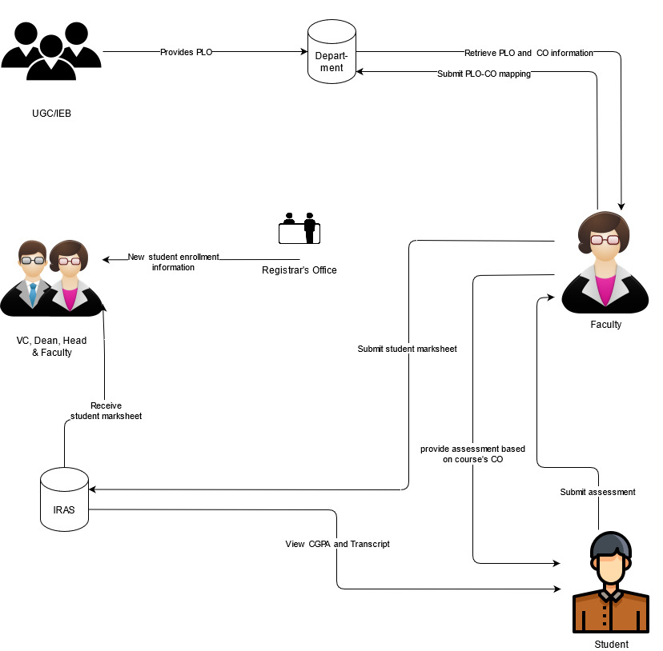

Figure: Rich Picture As-Is

### SIX ELEMENTS (AS-IS)

|  |  |  |  |  |  |  |
| --- | --- | --- | --- | --- | --- | --- |
| Process | System Roles | | | | | |
| Human | Non-Comp  Hardware | Computing Hardware | Software | Database | Network &  Communication |
| RECEIVE NEW STUDENT ENROLLMENT INFORMATION | **Registrar office:**  1)log in to computer  2) Receive request for enrolment information from VC, head of department, faculty, and dean.  3) Retrieve enrollment information from registrar office’s DB  4) Provide requested enrolment information to faculty, dean, head of department, VC as soft copy or printed copy.  **Faculty, dean, head of department, VC:**  1) log in to computer  2) Sends request for student enrollment information to registrar’s office.  3) Receive enrollment student information from registrar’s office. | **Paper and Stationary:**  Send student enrollment information as printed copy to VC, head of department, faculty, and dean.  **Folders**  Store student enrolment information as printed copies. | **Computer:**  1) Used by registrar office employees to send and/or receive new enrolment information to VC, head of department, faculty, and dean.  2) Used by VC, head of department, faculty, and dean to request and receive new student enrollment information.  **Registrar’s Office DB server :**  Used registrar’s office store student enrollment information  **Printer:**  To print new student enrollment information.  **Networking Device:**  Used for internet access, internal database access or communicational use. | **Operating System:**  Used in Registrar’s office, VC, head of department, faculty and dean’s computer.  **Email client:**  Used by Registrar’s office, VC, head of department, faculty and dean to send and receive new student information.  **Office suite:**  Used by VC, head of department, faculty and dean to generate enrollment trend. | **RDBMS:**  Used by Registrar’s office database to store new student enrollment information.  **Excel Files:**  Used to store new student enrollment information in local computer. | **Internet:**  Used to send or receive student enrollment information between Registrar’s office and VC, head of department, faculty, dean  **Telephone:**  Used for verbal communication between Registrar’s office and VC, head of department, faculty and dean. |
| Receive student mark-sheet | **VC, head of department, faculty, dean :**  1) Log in to their corresponding IRAS account.  2) Search for course wise, semester wise department wise student mark-sheet.  3) Download the mark-sheet. | **Paper and Stationary:**  Used to print the downloaded mark-sheet.  **Folder :**  Store the printed mark-sheet. | **Computer:**  Used by VC, head of department, faculty, and dean to retrieve and download student mark-sheet from their IRAS account.  **printer:**  Used by VC, head of department, faculty, and dean to print downloaded mark-sheet.  **IRAS DB server:**  Used by IRAS to store student mark-sheet.  **Networking device:**  Used for internet access, internal database access | **Operating system:**  Used in VC, head of department, faculty and dean’s computer.  **IRAS:**  To retrieve mark-sheet.  **Office suite:**  Used by VC, head of department, faculty and dean to generate student performance trend. | **RDBMS:**  Used by IRAS to store student mark sheet.  **Excel Files:**  Used to store student mark-sheet local computer. | **Internet:**  Used by VC, head of department, faculty, dean to retrieve student mark sheet from their corresponding IRAS account. |
| View CGPA and Transcript | **Student:**  1) Students have to login to their IRAS account at first  2) They can view their CGPA from their IRAS dashboard  3)In order to view their transcript, they have enter year and semester from their dashboard and click on “Transcript” button to download the transcript of that particular semester | **Paper:**  May be used by students to print their transcript  **Folder:**  To store the printed transcript | **Computer:**  Used by students to visit the IRAS website and view CGPA and transcript  **Printer:**  Used by students to print the transcripts  **IRAS DB server:**  Used by IRAS to store student CGPA and transcripts  **Networking device:**  Used for internet access, internal database access | **Operating system:**  Used in students’ computer.  **IRAS:**  To retrieve student CGPA and mark-sheet.  **PDF Viewer:**  Used to students view the downloaded transcripts | **RDBMS:**  Used by IRAS to store student CGPA and transcripts | **Internet:**  Used by students to login to their IRAS account and access their CGPA and transcripts. |
| Record student assessments and submit mark-sheet | **Faculty:**  1)Take classes, record student attendance and student class participation  2) Request department for PLO and CO information of a particular course  3) Receive and download PLO and CO from department  4) Set assignment and exam paper based the CO.  5) Organize schedule and room for exam and notify students.  6) Collect exam paper and assignment from students.  7) Checks the assignment and exam paper and records marks on mark-sheet  8) Log in to IRAS and Submits mark-sheet to IRAS.  **Department:**  1) Receive request for PLO and CO for a particular course from faculties  2) Send PLO and CO to faculties  **Student:**  1) Attend classes and participates in class discussion  2) Receives assignment and exam notifications from faculties  3) Attempts assignment problems and submits them to faculties  4) Takes exam on designated schedule and classroom and submits exam paper to faculties | **Pen and paper:**  1) Usedby department to send PLO and CO as printed form to faculty.  2) Used by teacher to make exam paper and assignment.  3) Used by student to take exam and assignment.  **Folder:**  Used by department student and faculty to store paper. | **Computer:**  1) Used by faculty to create assignment and exam paper.  2) Used by department to store PLO and CO information.  3) Used by student to view exam paper or assignment.  **IRAS DB server:**  Used by faculty to store student mark sheets.  **Printer:**  1) Used by department to print PLO and CO information.  2) used by faculty to print assignment and exam paper  **Networking device:**  Used for internet access, internal database access | **Operating system:**  Used in faculty, department and student’s computer.  **Office suite:**  Used by faculty to create assignment and exam paper. | **RDBMS:**  Used by faculty to store student mark sheets in IRAS DB. | **Internet:**  1) Used by faculty and department to receive and send PLO and CO information.  2) Used by student, faculty and department to communicate.  **Telephone:**  Used for verbal communication between faculty and student. |
| PLO CO mapping | **Faculty:**  1) Request department for PLO and CO information.  2)receive PLO and CO information from department  3) Download the PLO co information.  4) Discuss with otherfaculty member to create PLO and CO map.  5)sends PLO CO map to department  **Department:**  1) Receive request from faculty for PLO and CO information.  2) Send PLO and CO information to faculty.  3) Receive PLO and CO mapping from faculty.  4) Store PLO co map.  5) Download the PLO co map. | **Pen and paper:**  Used by faculty to view PLO and CO information as printed form. | **Computer:**  Used by faculty and department to receive and send PLO and CO information.  **Printer:**  Used by faculty to print the PLO and co information. | **Operating system:**  Used in department and faculty’s computer.  **PDF viewer:**  To see the PLO and co information. |  | **Internet:**  Used by faculty and department to receive and send PLO and CO information and communicate with each other.  **Telephone:**  Used for verbal communication between faculty and department. |

### BUSINESS PROCESS DIAGRAM (AS-IS)

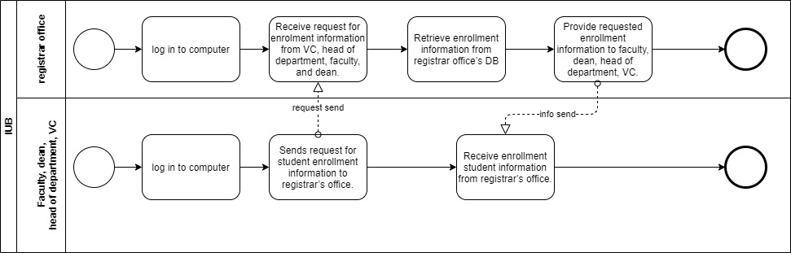

BPMN (AS-IS) FIGURE 1: View new enrollment data

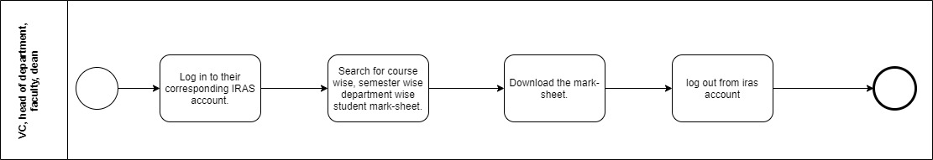

BPMN (AS-IS) FIGURE 2: View Student Mark-sheet by VC, Dean, Head, and Faculty

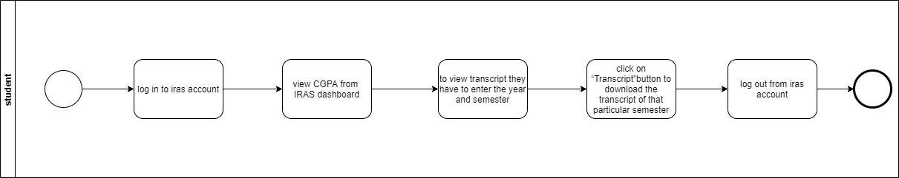

BPMN (AS-IS) FIGURE 3: View Transcript by Students

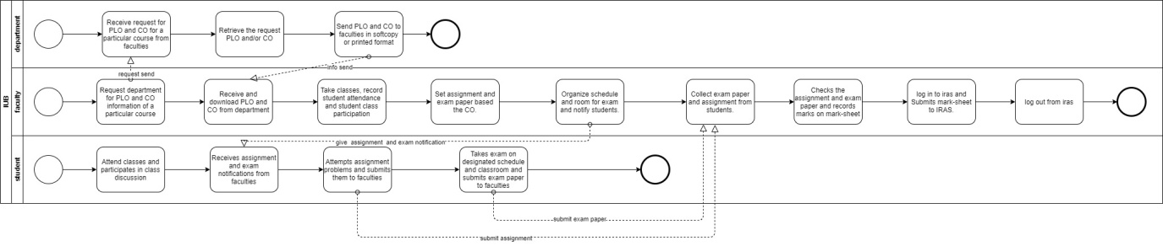

BPMN (AS-IS) FIGURE 4: Record Student Assessment

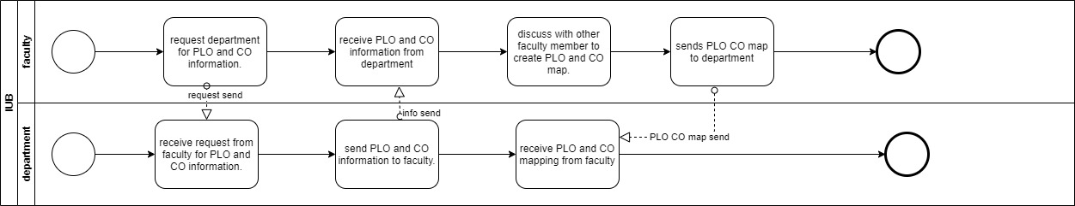

BPMN (AS-IS) FIGURE 5: Map PLO to CO

### PROBLEM ANALYSIS

|  |  |  |  |  |
| --- | --- | --- | --- | --- |
| Process Name(s) | Stakeholders | Concerns | Analysis | Proposed Solution |
| “Record Student Assessment and submit marksheet”, and “Map PLO CO” | Faculty  Department | Faculties have request the department to send PLO and CO details and the Department has to respond to the request | This process is time consuming as the request from the faculties has to receive by the department and retrieve necessary documents to be sent. Also, this process is resource consuming as well, as the faculty may have to send request using paper form or use any third party software for the task. | Rather than keeping the PLO and CO documents to themselves they will upload the documents to the SPM DB and faculties can easily access the files without needing to request the department |
| View new enrollment information | VC, Dean, Head, Faculty  Registrar’s Office  SPM Admin | In order to view the enrollment data, VC, Dean, Head and Faculty have send request to registrar’s office and in response the registrar’s office will send the data | This process can be time consuming and hard to manage over time, as the registrar’s office may have find manually for the request data. Also, the data sent may be just raw data and no overall trends will be shown. Users may have to use third party software to achieve that and if the data is hard copy version then generating trends will be even more difficult | Instead of requesting the registrar’s office, VC, Dean, Head and/or Faculties can view enrollment data from the enroll record on the SPM DB. Also, SPM software can show them a nice graphical analysis of enrollment |
| View Student CGPA Trend | VC, Dean, Head, Faculty | In order to see PLO achievement and CGPA trends of students, VC, Dean, Head and Faculty has to get the raw mark-sheet data from IRAS | The mark-sheet that they download from IRAS contains raw course-wise marks for each student. It is hard the produce overall trend from the mark-sheet as they contains raw marks for specific courses. In order to generate the trends, they might require scripts to calculate the CGPA from the mark-sheet and keep track of all the entities. It becomes even complicated when they want to see trends for range of semester or for a particular department or program. Most of the users might not be skilled enough to write scripts themselves. | In order to solve this problem, the marksheets can stored to SPM DB and generate the desired trends whenever the users need them. |

### RICH PICTURE (TO-BE)

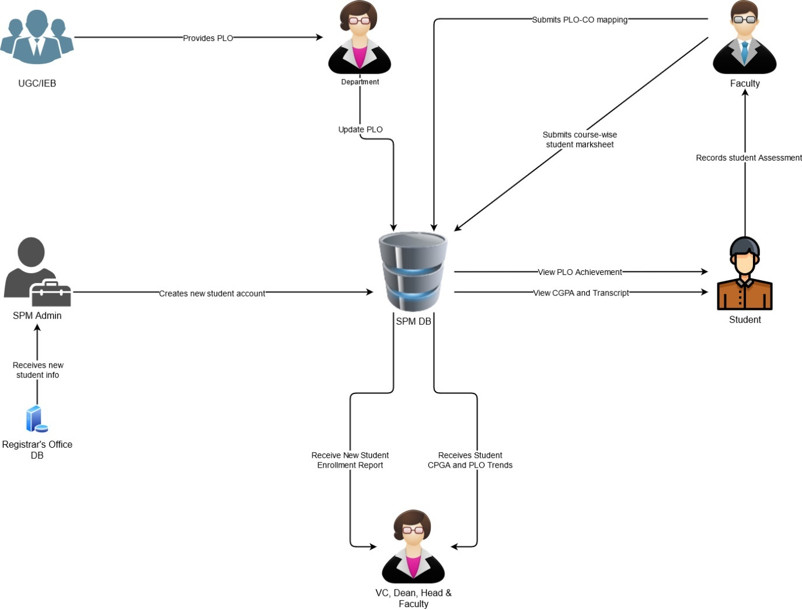

Figure: Rich Picture TO-BE

### SIX ELEMENT ANALYSIS (TO-BE)

|  |  |  |  |  |  |  |
| --- | --- | --- | --- | --- | --- | --- |
| Process | System Report | | | | | |
| Human | Non-computing Hardware | Computing Hardware | Software | Database | Internet & Communication |
| Create new students account | **SPM Admin:**  1)Receives new Students info from Registrar’s office database  2) Log in to SPM DB.  3) Generate new student accounts from provided information.  4) Log out from SPM DB. | **Pen, Paper and Stationeries:**  1) May be used by SPM admin note-down any corrupted information sent from registrar’s office | **Computer:**  1)Used by SPM Admin to receives data from registrar’s office database & generate new Students accounts  **Database Server:**  1)Registrar’s office DB from which new students information will be sent  2)SPM DB in which new students account will be stored | **Operating System:**  Used by SPM Admin to operate their computer  **Office Suite:**  May be used to store information locally in Excel format | **RDBMS:**  1) Used by both SPM DB & Registrar’s office DB to stored information  **Excel Software:**  May be used to store information locally in Excel format | **Internet:**  1) Used to access and modify SPM database  2)Communicate between SPM Admin & Registrar’s office  **Telephone:**  Used for verbal communicate between SPM Admin & Registrar’s office |
| Update PLO on SPM DB | **Department:**  1) Gets PLO from UGC/IEB  2) Log in to SPM DB.  3) Stores PLO in SPM DB  4) Log out from SPM DB.  **UGC/IEB:**  Send PLO to department | **Pen, Paper and Stationeries:**  1) May be UGC/IEB Send printed version of PLO. | **Computer:**  1) Used by UGC/IEB to send PLO  2) Used by department to store PLO  **Database Server:**  Store PLO information for SPM | **Operating System:**  Used by both department and UGC/IEB to operate their computer  **Office Suite:**  Used by UGC/IEB to create or modify PLO | **RDBMS:**  Used for SPM DB to stored PLO information | **Internet:**  1) Used by UGC/IEB to provide PLO to department  2) Used by department to stored PLO in SPM DB  3) Used to communicate between department and UGC/IEB  **Telephone:**  Used for verbal communication between department and UGC/IEB |
| Record student assessment and submit mark-sheet | **Faculty:**  1)Take classes, record student attendance and student class participation  2)Log in to SPM DB.  3) Fetch PLO and CO information of a particular course from SPM  4) Set assignment and exam paper based the CO.  5) Organize schedule and room for exam and notify students.  6) Collect exam paper and assignment from students.  7) Checks the assignment and exam paper and records marks on mark-sheet  8) Log in to SPM and Submits mark-sheet.  9) Log out.  **Student:**  1) Attend classes and participates in class discussion  2) Receives assignment and exam notifications from faculties  3) Attempts assignment problems and submits them to faculties  4) Takes exam on designated schedule and classroom and submits exam paper to faculties | **Pen, Paper and Stationeries:**  1) May be used by students to take lecture, write assignments, reports or take exam.  2) May be used by faculty to write lecture outline or print exam questions  **Folder:**  May be used by teacher to store students’ assignments, exam papers or mark sheet | **Computer:**  1) May be used by student to send assignments, reports or take online exams  2) May be used by faculties to view and mark the given reports, assignments or exams  **Database Server:**  Used by SPM DB store student mark sheets | **Operating System:**  1) Used by both faculties and students to operate their computers  **Office suite:**  1) Used by students to write assignments and reports  2) Used by faculty to write lecture outline or print exam questions  **Google Classroom and Google Form:**  May be used for online classes and online examination | **RDBMS:**  Used to store students’ course wise mark sheet to SPM DB  **Excel Sheet:**  Used by faculties to store student mark sheets locally | **Internet:**  1) Used by students to submit the reports, assignments or take online exams  2) Used by faculty to receive student assessment  3) Used by teacher to store students course wise mark sheet to SPM DB  4) Communicate between student and teacher |
| Update PLO-CO mapping to SPM DB | **Faculty:**  1) Login to SPM and retrieve PLO and CO information for a certain course from SPM  2) Discuss PLO-CO among several faculties  3) Map PLO-CO  2) Submit PLO-CO mapping in SPM DB | **Pen, Paper and Stationeries:**  1) May be used by faculty to print the PLO-CO mapping | **Computer:**  1) Used by faculty to view PLO chart and submit PLO-CO mappings  **Printer:**  May be used by faculty to print the PLO-CO mapping  **Database Server:**  Used by SPM to store PLO info and PLO-CO mappings | **Operating System:**  Used by faculty to operate their computer  **Printing software:** May be used by faculty to print the PLO-CO mapping | **RDBMS:**  Used by SPM DB to store PLO-CO mapping | **Internet:**  1) Used by faculty to store the PLO-CO mapping  2) Used to communicate with faculties and higher authorities  **Telephone:**  Used for verbal communication between faculties and higher authorities |
| View student CGPA, transcript and PLO achievements | **Student:**  1) Login to SPM and move the “achievements”.  2) CGPA will be displayed by default  3) To view transcript, they have to enter semester and year.  4) PLO achievements will be displayed on the dashboard | **Paper:**  May be used to print transcript  **Folder:**  May be used by store printed transcripts | **Computer:**  Used to view or download, PLO achievements, CGPA and transcripts  **Database Server:**  Used by SPM to store student mark sheets | **Operating System:**  Used by students to operate their computer  **Printing software:** May be used to print transcript  **PDF Viewer:**  Used to view transcripts in printable format | **RDBMS:** Used by SPM DB to store student mark sheets  **Excel Sheet:**  May be used by students to store CGPA locally | **Internet:**  Used by students to access SPM and view their CGPA and transcripts |
| Receive student CGPA and PLO trends | **VC, Dean of School, Head of Department and Faculties:**  1) Login to their SPM account  2) They have to enter semester range to view the CGPA and PLO achievements trends.  3) They can optionally enter particular school, department or program to view overall CGPA and PLO achievements  4) Leadership team can also view faculty-wise student CGPA and PLO achievements  5) Faculties can view overall CGPA and PLO achievements for students instructed by them. | **Pen and paper:**  Used by the users to note down any particular trends in CGPA and PLO  **Folder:**  Used to store the papers | **Computer:**  Used to view CGPA and PLO trends  **Database Server:**  Used by SPM to store student CGPA and PLO trends | **Operating System:**  Used by the users to operate their computer | **RDBMS:** Used by SPM DB to store student CGPA and PLO trends | **Internet:**  Used by the users to access SPM and view their CGPA and PLO trends |

### BUSINESS PROCESS DIAGRAM (TO-BE)

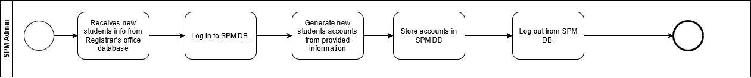

BPMN (TO-BE) FIGURE 6: Create new studentaccount

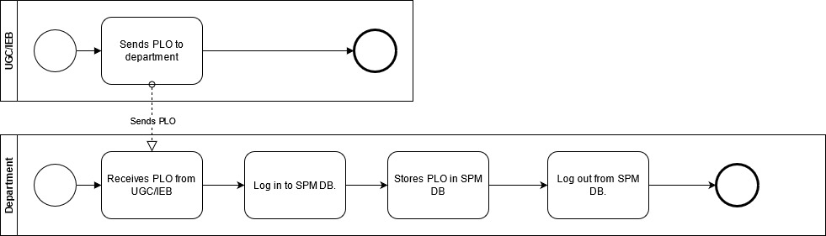

BPMN (TO-BE) FIGURE 2: Update PLO on SPM DB

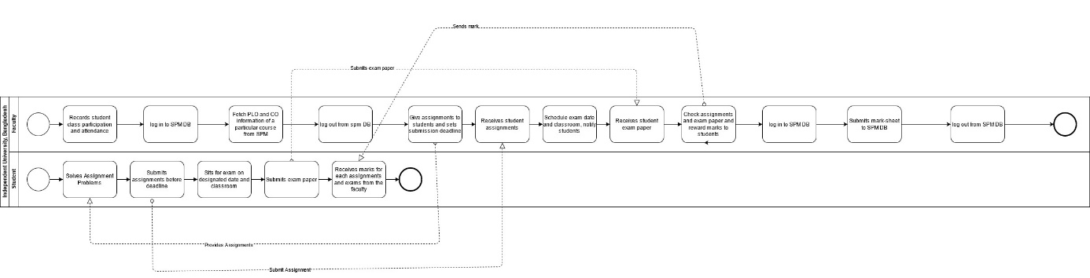

**BPMN (TO-BE) FIGURE 3: Record student assessment and submit mark-sheet**

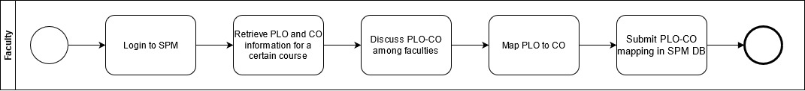

BPMN (TO-BE) FIGURE 4: Update PLO-CO mapping to SPM DB

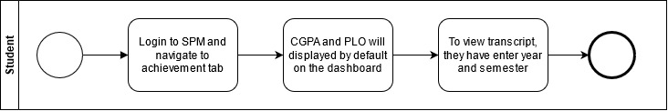

**BPMN (TO-BE) FIGURE 5: View student CGPA, transcript and PLO achievements**

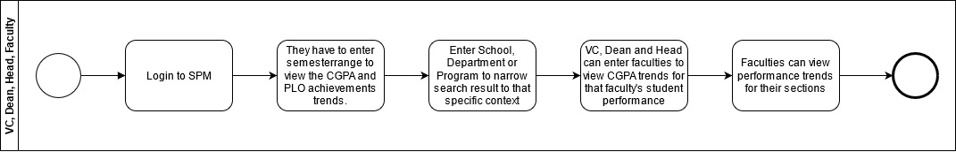

**BPMN (TO-BE) FIGURE 6: Receive student CGPA and PLO trends**

**Business Rule**

A department is enrolls multiple students. Each student is enrolled by exactly one department. A department must belongs to exactly one school. A school is consist of many department. A department must have exactly one head of department. A head of department is belongs to exactly one department. A department must employee many faculty. A faculty is employed by exactly one department.

A student is enrolls to exactly one section. Each section must have many students. A faculty is assign to many section. A section must have exactly one faculty. A course is assign to many section. A section must contains exactly one course. A section may assign many assessment. Each assessment is assign by exactly one section.

An assessment is assign to many student. Each student must receive many assessment. An assessment must have multiple Cos. A CO is belongs to exactly one assessment.

A CO is belongs to exactly one course. A course must have many Cos. A CO is belongs to exactly one PLO. A PLO must have many COs.

A PLO is stored by exactly one department. A department must store many PLOs. A PLO is contain by exactly one program. A program must consist of many PLOs.

A program is enrolls many student. Each student is enrolled by exactly one program. A program must belongs to exactly one department. A department is consist of many program.

A school must have exactly one dean of school. A dean of school is belongs to exactly one school. A school must belongs to exactly one university. A university is consist of many school.

A university must have exactly one VC. A VC is belongs to exactly one university.

A student may submit many assessment answer. An assessment answer must submitted by exactly one student. A student must receive grade from exactly one mark sheet. A mark sheet must send grade to many students.

**ERD**

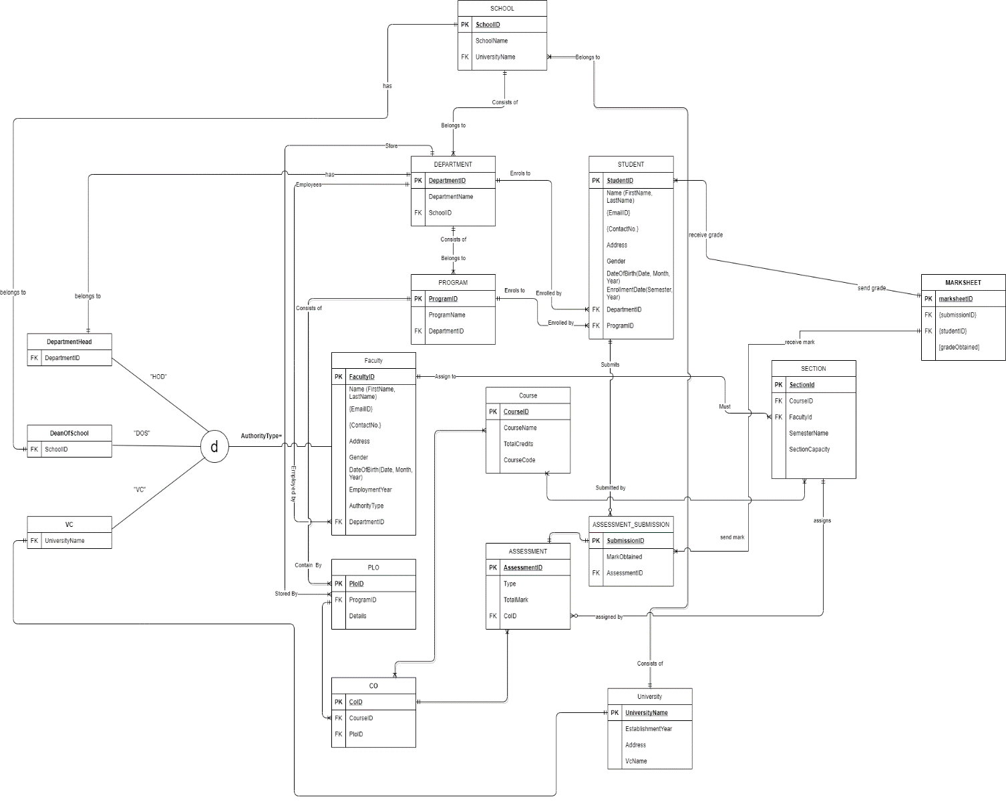

**RELATIONAL SCHEMA**

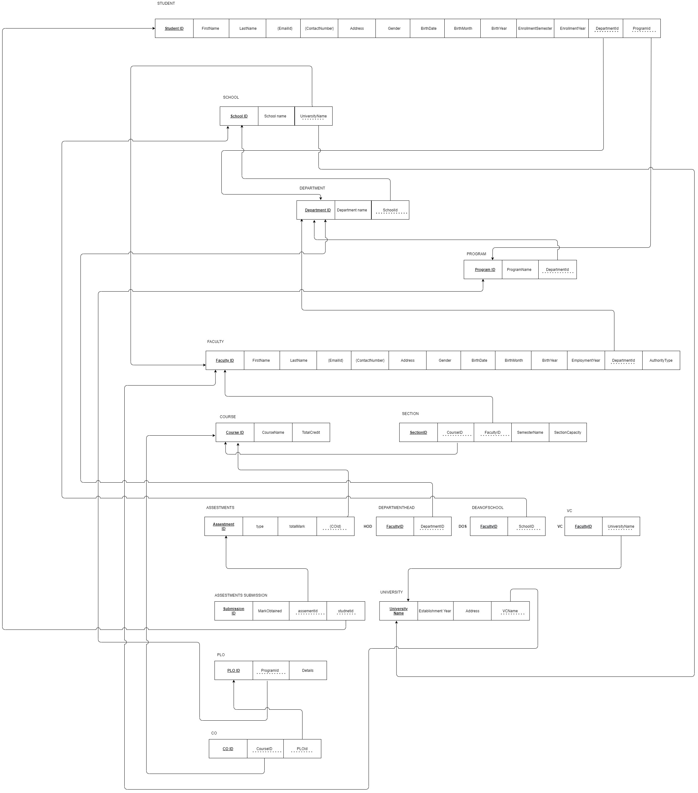

**NORMALIZATION**

**1NF:** In the schema we need to remove all the multivalued attributes.

**2NF:** In thisschema there will be no partial dependencies.

**3NF:** In this schema we have to remove transitive dependencies.

**BCNF:** Remove remaining anomalies resulting from multiple candidate keys.

**DATA DICTONARY:**

tblcourse

|  |  |  |  |
| --- | --- | --- | --- |
| Name | Data type | Size | remark |
| ccourseID | Text |  | This is the primary key of the course. Example:cse303 |
| ccourseName | Text |  | This is the name of the course. example: database management |
| ntotalCredit | Number |  | This is the credit of the course. Example:4 |

tbluniversity

|  |  |  |  |
| --- | --- | --- | --- |
| Name | Data type | Size | Remark |
| cuniversityName | Text |  | This is the primary key and name of the university. Example: Independent University, Bangladesh |
| dEstablishmentYear | Datetime | yyyy | This is the year of Establish the university. Example:1993 |
| caddress | Text |  | This is the address of the university. Example: Plot 16 Block B, Aftabuddin Ahmed Road  Bashundhara R/A, Dhaka, Bangladesh |
| cVCName | Text |  | This is the name of the vice chancellor of the university. Example: Tanweer Hasan |

tblschool

|  |  |  |  |
| --- | --- | --- | --- |
| Name | Data type | Size | Remark |
| cschoolID | Text |  | This is the primary key of the school. Example:SETS |
| cschoolName | Text |  | This is the name of the school. Example: School of Engineering, Technology & Sciences |
| cuniversityName | Text |  | This is the foreign key from the university table. Example: Independent University, Bangladesh |

tbldepartment

|  |  |  |  |
| --- | --- | --- | --- |
| Name | Data type | Size | remark |
| cdepartmentID | Text |  | This s the primary key of the department. example: CSE |
| cdepartmentName | Text |  | This is the name of the department. example: computer science and engineering. |
| cschoolID | Text |  | This is the foreign key from the school table. Example:SETS |

tblprogram

|  |  |  |  |
| --- | --- | --- | --- |
| Name | Data type | Size | Remark |
| cprogramID | Text |  | This is the primary key of the program. |
| cprogramName | Text |  | This is the name of the program. |
| cdepartmentID | Text |  | This is the foreign key from the department table. Example:CSE |

tblstudent

|  |  |  |  |
| --- | --- | --- | --- |
| Name | Data type | Size | Remark |
| cstudentID | Text | 7 | This is the primary key of the student. Example: 1234567 |
| cstudentName | Text |  | This is the name of the student. Example: MR.Abdul Korim |
| cemailID | Text |  | This is the email of student. Example: [abdul@gmail.com](mailto:abdul@gmail.com) |
| ncontractNo | Number | 11 | This is the contract number of the student. Example:01911111111 |
| caddress | Text |  | This is the address of the student. Example: sector6, house 6, road 6 uttara,Dhaka |
| cgender | Text |  | This is the gender of the student. Example:male |
| ddateOfBirth | Date time | dd/mm/yy | This is the birth date of the student. Example:06/06/96 |
| denrollmentYear | Date time | yyyy | This is the enrollment year when the student got admitted in the university. Example:2016 |
| cdepartmentID | Text |  | This is the foreign key from department table. Example:CSE |
| cprogramID | Text |  | This is the foreign key from the program table. |

tblfaculty

|  |  |  |  |
| --- | --- | --- | --- |
| Name | Data type | Size | Remark |
| cfacultyID | Text | 5 | This is the primary key of the faculty. Example:11111 |
| cname | Text |  | This is the name of the faculty. Example: MR.gousul azom |
| cemailId | Text |  | This is the email address of the faculty. Example:gousul@gmail.com |
| ncontractNo | Number | 11 | This is the contract number of the faculty. Example:7654321 |
| caddress | Text |  | This is the address of the faculty. example:sector5,read5, house 5 uttara, dhaka |
| cgender | Text |  | This is the gender of the faculty. Example:male |
| ddateOfBirth | Date time | dd/mm/yy | This is birth time of the faculty. Example: 11/12/66 |
| demploymentYear | Date time | Yyyy | This is the employment year when the faculty joined as employee in the university. Example:2009 |
| cdepartmentID | Text |  | This is the foreign key from the department table. Example: CSE |

tblsection

|  |  |  |  |
| --- | --- | --- | --- |
| NAME | DATA TYPE | SIZE | REMARKS |
| csectionID | Text |  | This is the primary key of the section. Exmaple: CSE 303 SEC 01 |
| ccousrseID | Text |  | This is the foreign key from the course table. Example: cse301 |
| cfacultyID | Text |  | This is the foreign key from the faculty table. Exmaple:11554 |
| csemesterName | Text |  | This is the name of the semester. Example: Spring 2016. |
| nsectioncapacity | Number |  | This is the total capacity of a section. Example: 30. |

tblplo

|  |  |  |  |
| --- | --- | --- | --- |
| NAME | DATA TYPE | SIZE | REMARK |
| cploID | Text |  | This is the primary key of the PLO(Program Learning Outcome). Example:”PLO1” |
| cprogramID | text |  | This is the foreign key from the program table. Example: M.sc. |
| cdetails | Text |  | This is the details of the PLO. |

tblco

|  |  |  |  |
| --- | --- | --- | --- |
| NAME | DATA TYPE | SIZE | REMARKS |
| ccoID | Text |  | This is the primary key of the CO. Example “CO1” |
| ccourseID | Text |  | This is the foreign key from the course table. Example:”CSE303” |
| cploID | Text |  | This is the foreign key from the PLO table. Example: “PLO2” |

tblassessmentID

|  |  |  |  |
| --- | --- | --- | --- |
| NAME | DATA TYPE | SIZE | REMARKS |
| cassesmentID | Text |  | This is the primary of the assessment. |
| ctype | Text |  | This is the type of the assessment. Example:assignment |
| ntotalMarks | Number |  | This is the mark for the assessment. Example:25 |
| ccoID | Text |  | This is foreign key from the CO table.example:CO1 |

tblassessment submission

|  |  |  |  |
| --- | --- | --- | --- |
| NAME | DATA TYPE | SIZE | REMARKS |
| csubmissionID | Text |  | This is the primary key of the assessment submission. |
| nmarkObtained | Number |  | this is the mark obtained by a student. Example:7 |
| cassessmentID | Text |  | This is foreign key of the assessment ID. |

**Input - output:**

